Adding GTM
Placement:
Dev / Staging -
- Paste this code as high in the <head> of the page as possible:
<!-- Google Tag Manager -->
<script>(function(w,d,s,l,i){w[l]=w[l]||[];w[l].push({'gtm.start':
new Date().getTime(),event:'gtm.js'});var f=d.getElementsByTagName(s)[0],
j=d.createElement(s),dl=l!='dataLayer'?'&l='+l:'';j.async=true;j.src=
'https://www.googletagmanager.com/gtm.js?id='+i+dl;f.parentNode.insertBefore(j,f);
})(window,document,'script','dataLayer','GTM-MSX7R7F4');</script>
<!-- End Google Tag Manager -->

- Paste this code immediately after the opening <body> tag:
<!-- Google Tag Manager (noscript) -->
<noscript><iframe src="https://www.googletagmanager.com/ns.html?id=GTM-MSX7R7F4"
height="0" width="0" style="display:none;visibility:hidden"></iframe></noscript>
<!-- End Google Tag Manager (noscript) -->

Production:
- Paste this code as high in the <head> of the page as possible:

<!-- Google Tag Manager -->
<script>(function(w,d,s,l,i){w[l]=w[l]||[];w[l].push({'gtm.start':
new Date().getTime(),event:'gtm.js'});var f=d.getElementsByTagName(s)[0],
j=d.createElement(s),dl=l!='dataLayer'?'&l='+l:'';j.async=true;j.src=
'https://www.googletagmanager.com/gtm.js?id='+i+dl;f.parentNode.insertBefore(j,f);
})(window,document,'script','dataLayer','GTM-NXWW7L3J');</script>
<!-- End Google Tag Manager -->

- Paste this code immediately after the opening <body> tag:
<!-- Google Tag Manager (noscript) -->
<noscript><iframe src="https://www.googletagmanager.com/ns.html?id=GTM-NXWW7L3J"
height="0" width="0" style="display:none;visibility:hidden"></iframe></noscript>
<!-- End Google Tag Manager (noscript) -->

DataLayer Push
Placement: This code must be placed above the GTM <script> tag in the <head> of the document.

Object Path |  |  |  | Key | Data Type | Example | Notes
root |  |  |  | event | string | "page_init" | Bootstrap event. Fires once per page load.
environment |  |  |  | env | string | "production" | Controlled values: production, staging, qa, dev
environment |  |  |  | site | string | "gsusa_shop" | Stable site identifier. Low-cardinality.
environment |  |  |  | platform | string | "web" | Controlled values: web, mweb, ios_app, android_app
environment |  |  |  | version | string | "1.42.0" | Release/app version. Useful for debugging.
page |  |  |  | page_type | string | "council" | Controlled taxonomy (homepage, plp, pdp, cart, checkout, confirmation, search, account, etc.).
page |  |  |  | page_name | string | "council" | "council_alaska" | Stable internal page label. Not display copy. naming convention council – {{ council name }}
page |  |  |  | path | string | "/" | Should use window.location.pathname.
page |  |  |  | referrer | string | "https://google.com" | Use document.referrer. May be empty.
page |  |  |  | previous_page_path | string | "/checkout/confirmation" | Internal previous path if available. Do not infer from referrer.
page |  |  |  | title | string | "Girl Scouts Shop" | Use document.title.
page |  |  |  | language | string | "en-US" | From <html lang> or browser.
user |  |  |  | login_state | string | "logged_out" | Controlled: logged_in, logged_out
user |  |  |  | user_id | string | "u_7f3a91c2" | Gigya ID. Not email-derived. Null if not logged in.
user |  |  |  | user_type | string | "new_user" | Controlled: guest | new_user | returning_user | returned_customer – set to new new_user if account was created in the same day as session, returning_user if the user has no orders, returned_customer more than 1 order default to guess if non-known user
user | customer_type | string | "consumer" | Controlled: consumer, council administrator, vendor – be default set consumer, once the user identified based on login status or UX experience
user |  |  |  | audience_mode | string | "leaders” | Controlled: leaders | general. Set to leader if user toggles leader UX experience otherwise general

window.dataLayer.push({
event: "page_init",
environment: {
env: "production",
site: "gsusa_shop",
platform: "web",
version: "1.42.0"
},
page: {
page_type: "council",
page_name: "council",
path: window.location.pathname,
referrer: document.referrer,
previous_page_path: "/",
title: document.title || null,
language: document.documentElement.lang || navigator.language || null
},
user: {
login_state: "logged_out",
user_id: null,
user_type: "guest"
customer_type: "council administrator",
audience_mode: "leaders"
}

Council Data Layer Push
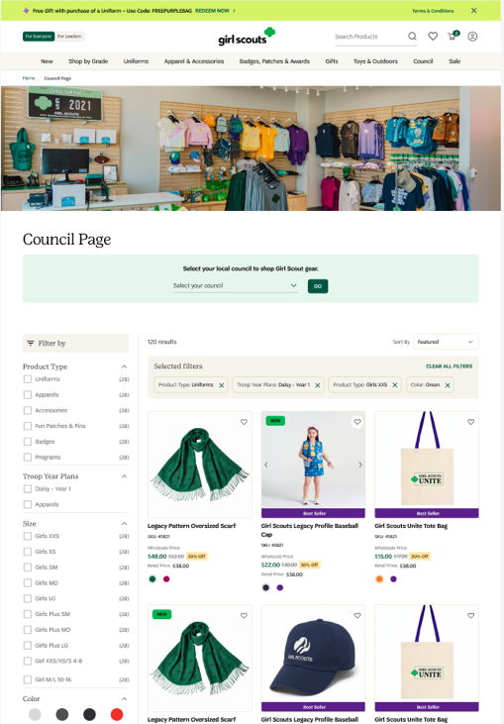
Business Questions:
What percentage of council views result in add_to_cart?
What percentage of council views result in purchase?
What is the average time from council view to purchase?
What is the revenue per council view?
Which products have the highest / lowest council-to-purchase conversion rate?
Does council engagement improve checkout completion rate?
How long do users spend on the council?
What is the CTR on items list within the Council?
Are users using council search feature?
Are users using council search feature have a higher conversion rate or likely to add-to-cart?

Council Search
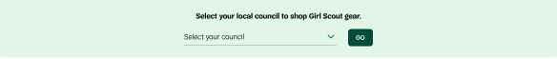

Object | Parameter Name | Data Type | Example Value | Description
root | event | string | "search" | Event name pushed to dataLayer
search | search.term | string | "Alaska" | council entered or selected
search | search.method | string | "selector" | How the search was initiated (manual input, selector, autocomplete, guided nav)
search | search.location | string | "header" | Page location where search was initiated
search | search.module | string | "council_search" | Module or UI component responsible for the search interaction
page | page.pagePath | string | "/council" | Current page path
page | page.pageType | string | "council" | Logical page classification

Search Results: Fire once the page object is initialed

Object | Parameter Name | Data Type | Example | Description
root | event | string | "view_search_results" | Name of the dataLayer event
search | search.term | string | "Alaska" | Search keyword entered or selected
search | search.method | string | "selector" | How search was initiated (manual, autocomplete, selector, guided_navigation)
search | search.location | string | "header" | UI location where search was triggered
search | search.module | string | "guided_navigation" | Specific component responsible for interaction
search | search.module | string | "council_search" | Module or UI component responsible for the search interaction
search | search.results_count | integer | null | Number of results returned for the query
page | page.pagePath | string | "/council" | Current page path
page | page.pageType | string | "council" | Logical page classification

Example Code:
On Search
window.dataLayer.push({
event: "search",
search: {
term: "uniforms",
method: "selector",
location: "header",
module: "council_search"
search_element: "drop_down",
search_result_count: 1,
destination: "/council_alaska” },
page: {
pagePath: window.location.pathname,
pageType: "homepage"
}
});

Results
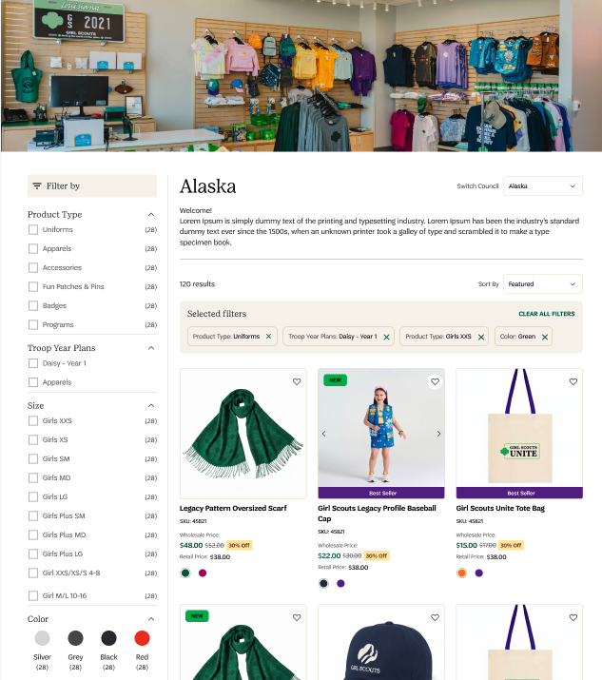
window.dataLayer.push({
event: "page_init",
environment: {
env: "production",
site: "gsusa_shop",
platform: "web",
version: "1.42.0"
},
page: {
page_type: "council ",
page_name: "council_alaska",
path: window.location.pathname,
referrer: document.referrer,
previous_page_path: "/council",
title: document.title || null,
language: document.documentElement.lang || navigator.language || null
},
user: {
login_state: "logged_out",
user_id: null,
user_type: "guest"
customer_type: "council administrator",
audience_mode: "leaders"
}

window.dataLayer.push({
event: "view_search_results",
search: {
term: " Alaska",
method: "selector",
location: "header",
module: "council_search",
search_element: "drop_down",
search_result_count: 10,
destination: "/council_alaska"
},
page: {
pagePath: window.location.pathname,
pageType: "homepage"
}
});

Council Item List
Fire once per ecommerce list view when all required fields are available:

Business Questions:
What is the revenue per module
Is there product position bias
What View-to-cart rate by slot
What Performance of “Recent Viewed block” vs other modules
What is ROI of merchandising
Assortment effectiveness?
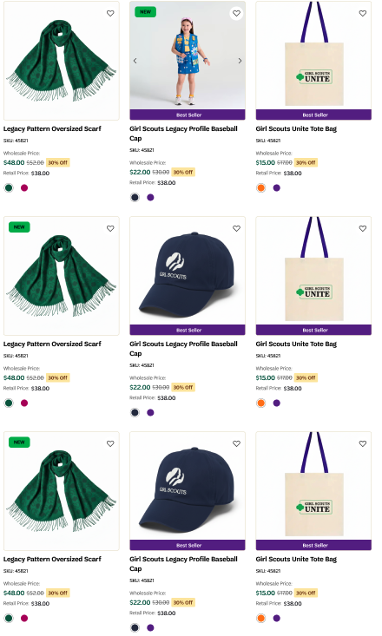

dataLayer Push: this should fire after the product data is available AND the module becomes visible.
Deployed instructions: Wait until product data is fully resolved
Wait until the module is visible in viewport (50% recommended)
Fire once per page load

Object Path | Parameter Name | Type | Example | Notes
root | event | string | "view_item_list" | Required. GA4 event name
root | page_type | string | "council" | plp / search / collection / home
root | list_type | string | "council" | category / search / collection / recommendation
root | list_id | string | "council_1234" | Stable ID across view/select
root | list_name | string | "Council 1234" | Human-readable council selected
root | schema_version | string | "ecom_v2.0" | Strongly recommended for governance
ecommerce | currency | string | "USD" | Required if sending value
ecommerce | value | number | 96 | Optional. Sum(price × quantity)
ecommerce | item_list_id | string | "council_1234" | Must match select_item
ecommerce | item_list_name | string | "Council 1234" | Must match select_item
ecommerce | items[] | array | [ {...} ] | Must contain ≥1 item
ecommerce.items[] | item_id | string | "SKU_10001" | Required. Prefer SKU
ecommerce.items[] | item_name | string | "Legacy Pattern Oversized Scarf" | No variant info unless standard
ecommerce.items[] | item_brand | string | "Girl Scouts Merchandising" | Recommended
ecommerce.items[] | item_category | string | "Accessories" | Level 1 taxonomy
ecommerce.items[] | item_category2 | string | "Scarves" | Optional
ecommerce.items[] | item_category3 | string | "Winter" | Optional
ecommerce.items[] | item_category4 | string | null | Optional
ecommerce.items[] | item_category5 | string | null | Optional
ecommerce.items[] | price | number | 48 | Numeric only
ecommerce.items[] | index | number | 1 | Required. 1-based position in list
ecommerce.items[] | item_variant | string | "Blue / Large" | Optional. Only if visible
ecommerce.items[] | quantity | number | 1 | Optional. Default = 1
ecommerce.items[] | discount | number | 5 | Only include if > 0
ecommerce.items[] | coupon | string | "WELCOME10" | Rare for list views
ecommerce.items[] | affiliation | string | "GSUSA Shop" | More common in purchase events
ecommerce.items[] | item_list_id | string | "apparel_outerwear" | Recommended for downstream joins
ecommerce.items[] | item_list_name | string | "Outerwear" | Same as above
ecommerce.items[] | location_id | string | "store_12" | Only for store context

Heart Click Tracking (Wishlist / Favorite)
When users heart a product
Object Path | Parameter Name | Data Type | Example Value | Description
root | event | string | "wishlist_add" | Name of the dataLayer event
root | wishlist_add_count | integer | 1 | Number of items added to wishlist (event count)
ecommerce | ecommerce | object | { ... } | Container for GA4-style ecommerce payload
ecommerce | currency | string | "USD" | (Recommended) ISO 4217 currency code
ecommerce | value | number | 28 | (Optional) Total value of wishlist action (sum of item price × quantity)
ecommerce.items | items | array | [ { ... } ] | Array of item objects associated with the wishlist action
ecommerce.items[] | item_id | string | "SKU_10002" | Unique product identifier (SKU)
ecommerce.items[] | item_name | string | "Structured Legacy Profile Baseball Cap" | Product name
ecommerce.items[] | item_brand | string | "Girl Scouts" | (Optional/Recommended) Product brand
ecommerce.items[] | item_category | string | "Accessories" | Primary product category
ecommerce.items[] | item_category2 | string | "Hats" | (Optional) Secondary category
ecommerce.items[] | item_category3 | string | null | (Optional) Tertiary category
ecommerce.items[] | item_category4 | string | null | (Optional) Category level 4
ecommerce.items[] | item_category5 | string | null | (Optional) Category level 5
ecommerce.items[] | item_variant | string | "Navy / One Size" | (Optional) Variant (color/size/style)
ecommerce.items[] | price | number | 28 | Unit price at time of wishlist action
ecommerce.items[] | quantity | integer | 1 | (Optional) Quantity associated with the wishlist action (default 1)
ecommerce.items[] | discount | number | 0 | (Optional) Discount amount applied to item
ecommerce.items[] | coupon | string | null | (Optional) Coupon code applied to item
ecommerce.items[] | affiliation | string | "GSUSA Shop" | (Optional) Store/site affiliation
ecommerce.items[] | index | integer | 2 | Product position in list/module
ecommerce.items[] | item_list_id | string | "pdp_related_item" | System ID of the list or module where item was shown
ecommerce.items[] | item_list_name | string | "Related Item" | Display name of the list/module where item was shown
ecommerce.items[] | location_id | string | null | (Optional) Physical store/location identifier (if applicable)

When a user unhearts a product

Object Path | Parameter Name | Data Type | Example Value | Description
root | event | string | "wishlist_remove" | Name of the dataLayer event
root | wishlist_remove_count | integer | 1 | Number of items added to wishlist (event count)
ecommerce | ecommerce | object | { ... } | Container for GA4-style ecommerce payload
ecommerce | currency | string | "USD" | (Recommended) ISO 4217 currency code
ecommerce | value | number | 28 | (Optional) Total value of wishlist action (sum of item price × quantity)
ecommerce.items | items | array | [ { ... } ] | Array of item objects associated with the wishlist action
ecommerce.items[].item_id | item_id | string | "SKU_10002" | Unique product identifier (SKU)
ecommerce.items[].item_name | item_name | string | "Structured Legacy Profile Baseball Cap" | Product name
ecommerce.items[].item_brand | item_brand | string | "Girl Scouts" | (Optional/Recommended) Product brand
ecommerce.items[].item_category | item_category | string | "Accessories" | Primary product category
ecommerce.items[].item_category2 | item_category2 | string | "Hats" | (Optional) Secondary category
ecommerce.items[].item_category3 | item_category3 | string | null | (Optional) Tertiary category
ecommerce.items[].item_category4 | item_category4 | string | null | (Optional) Category level 4
ecommerce.items[].item_category5 | item_category5 | string | null | (Optional) Category level 5
ecommerce.items[].item_variant | item_variant | string | "Navy / One Size" | (Optional) Variant (color/size/style)
ecommerce.items[].price | price | number | 28 | Unit price at time of wishlist action
ecommerce.items[].quantity | quantity | integer | 1 | (Optional) Quantity associated with the wishlist action (default 1)
ecommerce.items[].discount | discount | number | 0 | (Optional) Discount amount applied to item
ecommerce.items[].coupon | coupon | string | null | (Optional) Coupon code applied to item
ecommerce.items[].affiliation | affiliation | string | "GSUSA Shop" | (Optional) Store/site affiliation
ecommerce.items[].index | index | integer | 2 | Product position in list/module
ecommerce.items[].item_list_id | item_list_id | string | "pdp_related_item" | System ID of the list or module where item was shown
ecommerce.items[].item_list_name | item_list_name | string | "Related Item" | Display name of the list/module where item was shown
ecommerce.items[].location_id | location_id | string | null | (Optional) Physical store/location identifier (if applicable)

When a user selects an item
Object Path | Parameter Name | Data Type | Example Value | Description
root | event | string | "select_item" | Name of the dataLayer event
root | schema_version | string | "ecom_v2.0" | (Recommended) DataLayer schema version to prevent drift
ecommerce | ecommerce | object | { ... } | Container for GA4-style ecommerce payload
ecommerce | item_list_id | string | “council” | System ID of the product list/module – council for generic council page, or council_ {{council name}} ie council_alaska
ecommerce | item_list_name | string | "Council Alaska" | Display name of the product list/module
ecommerce | currency | string | "USD" | (Optional/Recommended) ISO 4217 currency code
ecommerce | value | number | 48 | (Optional) Total value of the selected item (typically equals item price × quantity)
ecommerce.items | items | array | [ { ... } ] | Array of selected item(s). Typically one item for select_item.
ecommerce.items[] | item_id | string | "SKU_10001" | Unique product identifier (SKU)
ecommerce.items[] | item_name | string | "Legacy Pattern Oversized Scarf" | Product name
ecommerce.items[] | item_brand | string | "Girl Scouts" | Brand associated with the product
ecommerce.items[] | item_category | string | "Accessories" | Primary product category
ecommerce.items[] | item_category2 | string | null | (Optional) Secondary category
ecommerce.items[] | item_category3 | string | null | (Optional) Tertiary category
ecommerce.items[] | item_category4 | string | null | (Optional) Category level 4
ecommerce.items[] | item_category5 | string | null | (Optional) Category level 5
ecommerce.items[] | item_variant | string | null | (Optional) Variant (size/color/style)
ecommerce.items[] | price | number | 48 | Unit price at time of click
ecommerce.items[] | quantity | integer | 1 | (Optional) Quantity (default 1)
ecommerce.items[] | discount | number | 0 | (Optional) Discount amount applied to item
ecommerce.items[] | coupon | string | null | (Optional) Coupon code applied to item
ecommerce.items[] | affiliation | string | "GSUSA Shop" | (Optional) Store/site affiliation
ecommerce.items[] | index | integer | 1 | Position of product within the list
ecommerce.items[] | item_list_id | string | "pdp_related_items" | (Optional/Recommended) Repeat list ID at item level for downstream joins
ecommerce.items[] | item_list_name | string | "Related Items " | (Optional/Recommended) Repeat list name at item level for downstream joins
ecommerce.items[] | location_id | string | null | (Optional) Physical store/location identifier (if applicable)

Example Code for Impression - Deployed instructions: Wait until product data is fully resolved
Wait until the module is visible in viewport (50% recommended)

window.dataLayer = window.dataLayer || [];
window.dataLayer.push({
event: "view_item_list",
ecommerce: {
currency: "USD", // Optional but recommended
value: 91.00, // Sum of item price * quantity (if relevant)
item_list_id: "council_alaska",
item_list_name: "Council Alaska ",
items: [
{
item_id: "SKU_10001",
item_name: "Legacy Pattern Oversized Scarf",
item_brand: "Girl Scouts",
item_category: "Accessories",
item_category2: null,
item_category3: null,
item_category4: null,
item_category5: null,
item_variant: null,
price: 48.00,
quantity: 1,
affiliation: "GSUSA Shop",
coupon: null,
discount: 0,
index: 1,
item_list_id: "pdp_related_items",
item_list_name: "Related Items",
location_id: null // e.g., physical store ID if ever applicable
},
{
item_id: "SKU_10002",
item_name: "Structured Legacy Profile Baseball Cap",
item_brand: "Girl Scouts",
item_category: "Accessories",
item_category2: null,
item_category3: null,
item_category4: null,
item_category5: null,
item_variant: null,
price: 28.00,
quantity: 1,
affiliation: "GSUSA Shop",
coupon: null,
discount: 0,
index: 2,
item_list_id: "pdp_related_items",
item_list_name: "Related Items",
location_id: null
},
{
item_id: "SKU_10003",
item_name: "GS Scouts Unite Tote Bag",
item_brand: "Girl Scouts",
item_category: "Bags",
item_category2: null,
item_category3: null,
item_category4: null,
item_category5: null,
item_variant: null,
price: 15.00,
quantity: 1,
affiliation: "GSUSA Shop",
coupon: null,
discount: 0,
index: 3,
item_list_id: "pdp_related_items",
item_list_name: "Related Items",
location_id: null
}
]
}
});

Heart Click Tracking (Wishlist / Favorite)
When users heart a product
window.dataLayer = window.dataLayer || [];
window.dataLayer.push({
event: "wishlist_add",
wishlist_add_count: 1,
ecommerce: {
currency: "USD",
value: 28.00,
item_list_id: "council_alaska",
item_list_name: "Council Alaska",
items: [
{
item_id: "SKU_10002",
item_name: "Structured Legacy Profile Baseball Cap",
item_brand: "Girl Scouts",
item_category: "Accessories",
item_category2: null,
item_category3: null,
item_category4: null,
item_category5: null,
item_variant: null,
price: 28.00,
quantity: 1,
discount: 0,
coupon: null,
affiliation: "GSUSA Shop",
index: 2,
item_list_id: "council_alaska",
item_list_name: "Council Alaska",
location_id: null
}
]
}
});

When a user unhearts a product
window.dataLayer = window.dataLayer || [];
window.dataLayer.push({
event: "wishlist_remove",
wishlist_remove_count: 1,
ecommerce: {
currency: "USD",
value: 28.00,
item_list_id: "council_alaska",
item_list_name: "Council Alaska",
items: [
{
item_id: "SKU_10002",
item_name: "Structured Legacy Profile Baseball Cap",
item_brand: "Girl Scouts",
item_category: "Accessories",
item_category2: null,
item_category3: null,
item_category4: null,
item_category5: null,
item_variant: null,
price: 28.00,
quantity: 1,
discount: 0,
coupon: null,
affiliation: "GSUSA Shop",
index: 2,
item_list_id: "council_alaska",
item_list_name: "Council Alaska",
location_id: null
}
]
}
});

Product clicks
window.dataLayer = window.dataLayer || [];
window.dataLayer.push({
event: "select_item",
ecommerce: {
currency: "USD", // Recommended if sending value
value: 48.00, // price * quantity (usually 1)
item_list_id: "council_alaska",
item_list_name: "Council Alaska",
items: [
{
item_id: "SKU_10001",
item_name: "Legacy Pattern Oversized Scarf",
item_brand: "Girl Scouts",
item_category: "Accessories",
item_category2: null,
item_category3: null,
item_category4: null,
item_category5: null,
item_variant: null,
price: 48.00,
quantity: 1,
discount: 0,
coupon: null,
affiliation: "GSUSA Shop",
index: 1,
item_list_id: "council_alaska",
item_list_name: "Council Alaska",
location_id: null
}
]
}
});

Promo
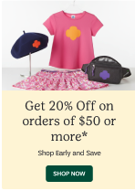
Business Questions:
What is the revenue per module
Are users engage with the promo
Are using ATC after engaging with the block

Impression
Attribute | Data Type | Requirement / Rule | Example
Attribute | Data Type | Requirement / Rule | Example
data-analytics-type | string | Required. Defines engagement category. Must follow controlled vocabulary. | "impression"
data-analytics-kind | string | Required. Classifies CTA (feature, promo, utility, content). | "promo"
data-analytics-location | string | Required. Logical placement on page. Must follow naming convention (e.g., hp_hero, hp_nav). | "promo_teaser"
data-analytics-module | string | Required. Identifies functional grouping or feature group. | "promo"
data-analytics-position | integer | Required. Positive integer. Position index within module starting at 1. | 1
data-analytics-label | string | Required. Human-readable slug. Lowercase, hyphen-separated, no spaces. | "shop_now"
data-analytics-id | string | Required. Globally unique CTA identifier. Must remain stable across releases. | "promo_shop_now"

Clickable item
Attribute | Data Type | Requirement / Rule | Example
data-analytics-type | string | Required. Must use controlled value (cta, hero_cta, nav_cta, etc.). | "cta"
data-analytics-kind | string | Required. Classifies the CTA (feature, promo, utility, content). | "promo"
data-analytics-location | string | Required. Logical placement on page using naming convention (hp_hero, hp_nav, plp, pdp). | "promo_teaser"
data-analytics-module | string | Required. Functional grouping or feature area. | "promo"
data-analytics-position | integer | Required. Positive integer. Position within module starting at 1. | 1
data-analytics-label | string | Required. Lowercase, hyphen-separated slug. No spaces. | "shop_now"
data-analytics-id | string | Required. Globally unique CTA identifier. Must remain stable across releases. | "promo_shop_now"

New Council Products | Popular from Local Councils | Council Bestsellers, etc.
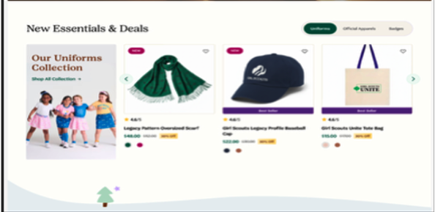
Business Questions
- What is the revenue per module
- Is there product position bias
- What View-to-cart rate by slot
- What Performance of “Recent Viewed block” vs other modules
- What is ROI of merchandising
- Assortment effectiveness?

Implementation
dataLayer Push: this should fire after the product data is available AND the module becomes visible.
Deployed instructions: Wait until product data is fully resolved
Wait until the module is visible in viewport (50% recommended)
Fire once per page load

Object Path | Parameter Name | Type | Example | Notes
root | event | string | "view_item_list" | Required. GA4 event name
root | page_type | string | "council" | plp / search / collection / home
root | list_type | string | "council" | category / search / collection / recommendation
root | list_id | string | "new_council_products" | Stable ID across view/select
root | list_name | string | "New Council Producs" | Human-readable council selected
root | schema_version | string | "ecom_v2.0" | Strongly recommended for governance
ecommerce | currency | string | "USD" | Required if sending value
ecommerce | value | number | 96 | Optional. Sum(price × quantity)
ecommerce | item_list_id | string | "alaska_council_bestsellers" | Must match select_item
ecommerce | item_list_name | string | "Alaska Council Bestsellers" | Must match select_item
ecommerce | items[] | array | [ {...} ] | Must contain ≥1 item
ecommerce.items[] | item_id | string | "SKU_10001" | Required. Prefer SKU
ecommerce.items[] | item_name | string | "Legacy Pattern Oversized Scarf" | No variant info unless standard
ecommerce.items[] | item_brand | string | "Girl Scouts Merchandising" | Recommended
ecommerce.items[] | item_category | string | "Accessories" | Level 1 taxonomy
ecommerce.items[] | item_category2 | string | "Scarves" | Optional
ecommerce.items[] | item_category3 | string | "Winter" | Optional
ecommerce.items[] | item_category4 | string | null | Optional
ecommerce.items[] | item_category5 | string | null | Optional
ecommerce.items[] | price | number | 48 | Numeric only
ecommerce.items[] | index | number | 1 | Required. 1-based position in list
ecommerce.items[] | item_variant | string | "Blue / Large" | Optional. Only if visible
ecommerce.items[] | quantity | number | 1 | Optional. Default = 1
ecommerce.items[] | discount | number | 5 | Only include if > 0
ecommerce.items[] | coupon | string | "WELCOME10" | Rare for list views
ecommerce.items[] | affiliation | string | "GSUSA Shop" | More common in purchase events
ecommerce.items[] | item_list_id | string | "apparel_outerwear" | Recommended for downstream joins
ecommerce.items[] | item_list_name | string | "Outerwear" | Same as above
ecommerce.items[] | location_id | string | "store_12" | Only for store context

window.dataLayer = window.dataLayer || [];
window.dataLayer.push({
event: "view_item_list",
ecommerce: {
currency: "USD", // Optional but recommended
value: 91.00, // Sum of item price * quantity (if relevant)
item_list_id: "alaska_council_bestsellers"",
item_list_name: "Alaska Council Bestsellers",
items: [
{
item_id: "SKU_10001",
item_name: "Legacy Pattern Oversized Scarf",
item_brand: "Girl Scouts",
item_category: "Accessories",
item_category2: null,
item_category3: null,
item_category4: null,
item_category5: null,
item_variant: null,
price: 48.00,
quantity: 1,
affiliation: "GSUSA Shop",
coupon: null,
discount: 0,
index: 1,
item_list_id: "alaska_council_bestsellers"",
item_list_name: "Alaska Council Bestsellers",
location_id: null // e.g., physical store ID if ever applicable
},
{
item_id: "SKU_10002",
item_name: "Structured Legacy Profile Baseball Cap",
item_brand: "Girl Scouts",
item_category: "Accessories",
item_category2: null,
item_category3: null,
item_category4: null,
item_category5: null,
item_variant: null,
price: 28.00,
quantity: 1,
affiliation: "GSUSA Shop",
coupon: null,
discount: 0,
index: 2,
item_list_id: "alaska_council_bestsellers"",
item_list_name: "Alaska Council Bestsellers",
location_id: null
},
{
item_id: "SKU_10003",
item_name: "GS Scouts Unite Tote Bag",
item_brand: "Girl Scouts",
item_category: "Bags",
item_category2: null,
item_category3: null,
item_category4: null,
item_category5: null,
item_variant: null,
price: 15.00,
quantity: 1,
affiliation: "GSUSA Shop",
coupon: null,
discount: 0,
index: 3,
item_list_id: "alaska_council_bestsellers"",
item_list_name: "Alaska Council Bestsellers",
location_id: null
}
]
}
});

Store Location Module
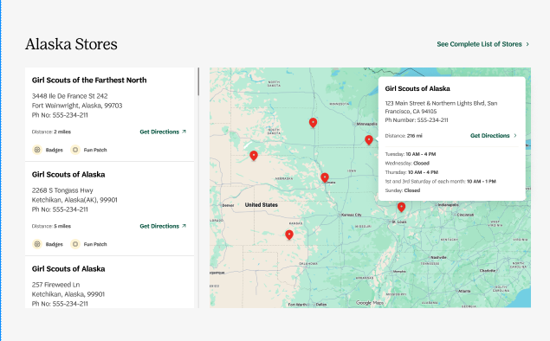
Impression
Attribute | Data Type | Requirement / Rule | Example
Attribute | Data Type | Requirement / Rule | Example
data-analytics-type | string | Required. Defines engagement category. Must follow controlled vocabulary. | "impression"
data-analytics-kind | string | Required. Classifies CTA (feature, promo, utility, content). | "store_locator"
data-analytics-location | string | Required. Logical placement on page. Must follow naming convention (e.g., hp_hero, hp_nav). | "map"
data-analytics-module | string | Required. Identifies functional grouping or feature group. | "store_locator"
data-analytics-position | integer | Required. Positive integer. Position index within module starting at 1. | 1
data-analytics-label | string | Required. Human-readable slug. Lowercase, hyphen-separated, no spaces. | "store_locator_map"
data-analytics-id | string | Required. Globally unique CTA identifier. Must remain stable across releases. | " store_locator_map"

Clickable table
Clickable item
Attribute | Data Type | Requirement / Rule | Example
data-analytics-type | string | Required. Must use controlled value (cta, hero_cta, nav_cta, etc.). | "cta"
data-analytics-kind | string | Required. Classifies the CTA (feature, promo, utility, content). | "promo"
data-analytics-location | string | Required. Logical placement on page using naming convention (hp_hero, hp_nav, plp, pdp). | "promo_teaser"
data-analytics-module | string | Required. Functional grouping or feature area. | "promo"
data-analytics-position | integer | Required. Positive integer. Position within module starting at 1. | 1
data-analytics-label | string | Required. Lowercase, hyphen-separated slug. No spaces. Format – store number – name- link type | "123-Girls Scouts of the Farthest North-Get Directions"
data-analytics-id | string | Required. Globally unique CTA identifier. Must remain stable across releases. | "promo_shop_now"

